Djel Ann Gallup Brown — Class of 1958
Djel is a community volunteer, former educator and businessperson. After receiving her bachelor’s and master’s degrees from Omaha University, she taught at Norris Junior
High and later at Bryan High. In between she was an adjunct English instructor at Metropolitan Community College. She was on the OPS desegregation committee, organized the Burke High Awareness Council and is an honorary lifetime PTA member. Her community activities have benefited the Omaha Symphony, Museum of Nebraska Arts, Assistance League, Lauritzen Gardens, St. Paul and St. Luke Methodist Churches, Children’s Hospital and, most recently,
Omaha Home for Boys. She owned two Corn Popper stores and a stationary and print store.

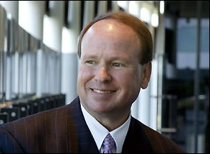 Donald R. Voelte Jr. — Class of 1971
Donald is a business executive in the fields of energy and news media.After earning his engineering degree at UNL, he rose through the ranks in 22 years at Mobil Oil in exploration
and three at Atlantic Richfield in global growth and risk management. At Chroma Energy in
Houston he was the president and CEO before leaving to head Australian’s Woodside Petroleum. He stayed in Australia after retiring from Woodside to run Seven West Media Ltd until 2015, when he returned to the U.S. to form VoKe Energy. Donald and his wife, Nancy Keegan, have endowed chairs at UNL in engineering and the other in neurosurgery
and donated to create the Voelte-Keegan Nanoscience Research Center. The Australian government recently made him honorary officer within the general division of the Order of Australia.

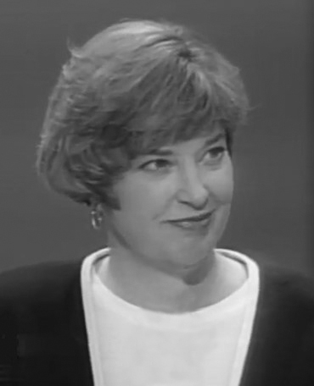 Alice (Ally) Milder — Class of 1973 (deceased)
Ally was an attorney who entered politics and worked on humanitarian efforts. She was a lobbyist before her death in 2005. A 1980 graduate of the Creighton Law School, she
joined the Senate Judiciary Committee as a staff counsel for Charles Grassley (R-Iowa) and was promoted to chief counsel and staff director. She founded the International Parliamentary Group for Human Rights in the Soviet Union. Returning to Nebraska, she served four years on the State Board of Education and twice ran unsuccessfully for Congress. Her lobbyist career included working for Union Paci􀏐ic as director of government affairs and supervising state-level lobbyists. She was honored by the Nebraska Children and Families Foundation and the American Jewish Historical Society. The Omaha Schools Foundation oversees her memorial scholarship.

Amy Quist Black — Class of 1986
Amy is an economics professor at Hastings College,
her alma mater. While at Benson High, Amy was a part of the academic decathlon team coach by Gary Manning. One of the categories that year was economics, which piqued
her interest. She majored in economics at Hastings and earned her PhD in the 􀏐ield at Notre Dame. At Hanover until 2001, she returned to Hastings and now teaches courses in macroeconomics, money and financial markets, economic development and extreme
economics. She is the co-faculty advisor for the Omicron Delta Epsilon economics honorary. She teaches K-12 economics through literature, the Nature Explore/Outdoor Classroom Project and Heifer International.

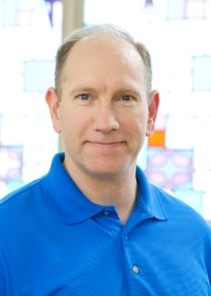 Robert (Robb) Gottsch — Class of 1988
Robb is an Omaha Fire Department battalion chief. A Navy veteran, he earned his undergraduate degree at UNL and in 2016 his master’s in public administration
from UNO. He has been on the OFD force since 1993 and has been a captain in 􀏐ire suppression and 􀏐ire investigation before rising to his current position in 2012.
He teaches part-time at UNO and has been vice president of the Nebraska Chamber of the International Associations of Arson Investigators.

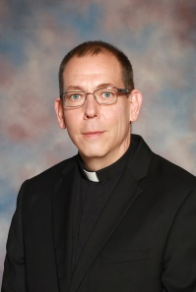 Rev. Patrick McLaughlin — Class of 1988
Father Patrick serves the St. Francis of Assisi parish in Humphrey, Nebraska, as its pastor and the president of its school. Before the priesthood, he received his undergraduate
degree chemistry from UNO and a PhD in inorganic chemistry from Iowa State in 1998. He entered the seminary in Conception, Missouri, and was ordained in 2003. His previous parishes before St. Francis have included St. Vincent DePaul in west Omaha and the St.
Augustine Indian Mission in Winnebago as an associate pastor and St. Wencelaus in Dodge as pastor. He also taught at West Point Central Catholic

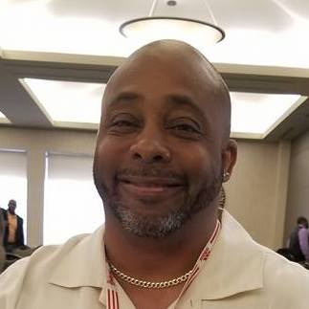 Terrence Mackey — Class of 1979 (Booster Graduate)
Terrence is the north Omaha gang prevention specialist for the Omaha Police Department.
In March he was hired as Benson High’s next football coach. He was on the Douglas County Youth Center staff for more than 15 years before becoming only the third gang specialist for OPD. He also works with the Boys and Girls Club of the Midlands and is a volunteer
coach.
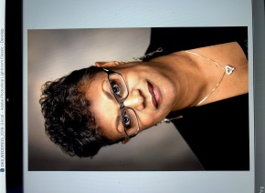 Millie Tucker Lemon — Booster
Millie is a retired Omaha Public Schools educator who was at Benson for 20 years.
A graduate of UNO, from which she received a master’s degree in counseling, she taught five levels of Spanish besides World History and sociology at Benson. She sponsored many clubs, committees and organizations while at Benson. At Bryan she was a counselor for 10 years.
Her volunteer work continues at Glad Tidings Church.

Benson High School’s Hall of Fame Committee selected the above to be inducted into the Benson Hall of Fame on Friday, April 20th, at 7:30 pm in the Benson High School Mary McNamara Auditorium during a formal ceremony. The public is welcome to attend.

